The One With Ross and Monica’s Cousin

Written by: Andrew Reich & Ted Cohen
Transcribed by: Eric Aasen
719 罗斯和莫妮卡的表亲
乔伊想演一部电影的男主角，但导演要求正面全裸的镜头。
乔伊壮起胆子说没问题，之后莫妮卡帮他找了各种材料用来遮羞，而他选择了橡皮泥。
在最后一场试镜时，遮羞物掉了下来。
瑞秋和菲比发现她们都很期待扔莫妮卡的花束，于是她们迅速做了花束。
罗斯和莫妮卡的表亲Cassie来访并小住。
她相当迷人，钱德看得目不转睛；
罗斯向她发动攻势；
连菲比也动心了。
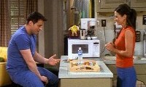
7.19 The One With Ross And Monica's Cousin
Joey is up for a leading role in a movie, but the director is looking for an uncircumcized(adj.未行过割礼的) male to do a nude scene.
Joey claims he's not circumcized, and then Monica helps him by making a variety of attachments to choose from.
(He chooses Silly Putty.)
But the piece falls off during Joey's final audition.
Rachel and Phoebe realize they're expected to throw Monica a bridal shower, so they quickly put one together.
Ross and Monica's cousin Cassie comes to visit for a few days.
She's so drop-dead(adj.极其吸引人的) gorgeous that Chandler can't stop staring;
Ross makes a move on her;
And Phoebe considers her options as well. [Scene: Central Perk, Monica and Phoebe are on the couch as Joey enters.]
Phoebe: (To Joey) Oh hey! How was your audition?
Joey: I’m sorry, do I know you?
Phoebe: What are you doing?
Joey: Nothing, I’m just practicing blowing you off because I’m gonna be a big movie star!
blow off <俚> ignore
Phoebe: Oh! You got it?!
Joey: Well, no not yet. But the audition went really good.
Monica: What was it for?
Joey: Oh, it’s this big budget period movie about these three Italian brothers who come to America around the turn of the century. It’s really classy! Oh, and the director is supposed to be the next, next Martin Scorsese.
period a. 某一时代(特有)的/classy adj.上等的/Martin Scorsese：乔伊有望成为大制作电影的一名演员，其中的导演据他说有望成为“下一个马丁·斯科塞斯(Martin Scorsese)”。斯科塞斯是好莱坞最著名的导演之一，曾导演过《纯真年代》、《恐怖角》、《好家伙》、《基督最后的诱惑》、《金钱本色》和《出租车司机》等名片/ Martin Marcantonio Luciano Scorsese (born November 17, 1942) is an Academy Award, Golden Globe, BAFTA[abbr.(英国)电影和电视艺术学院], and Directors Guild(n.行业协会) of America award winning American film director, writer and producer.Scorsese's body of work addresses such themes as Italian-American identity, Roman Catholic(adj.天主教会) concepts of guilt and redemption(n.赎回),machismo(n.男子气概), and the violence endemic(n.地方病) in American society. Scorsese is widely considered to be one of the most significant and influential American filmmakers of his era. He earned an MFA(abbr.Master of Fine Arts 美术硕士) in film directing from the prestigious NYU Film School. He won the Academy Award for Best Director for his film The Departed, which also won the Academy Award for Best Picture at the 79th Academy Awards in 2007.
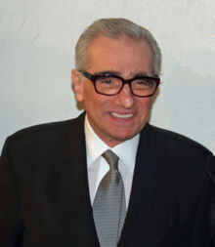
Phoebe: The next, next?
Joey: Yeah, there’s this guy from Chicago who’s supposed to be the next Martin Scorsese, all right? But then this guy’s right after him. (Joey’s cell phone rings and he answers it.) Hello!
Estelle: Joey! It’s Estelle! I just talked to the casting people; they loved you!
casting people n.(负责)选角人员
Joey: (to Monica and Phoebe) They loved me!
Estelle: Yeah, they wanna see you again tomorrow.
Joey: (on phone) Oh my God!
Estelle: There’s just one thing. Do you have a problem with full frontal nudity?
frontal adj.正面的 前面的/nudity n.赤裸
Joey: Are you kidding me? I never rent a movie without it! (Realizes) Oh. (Listens) Uh, okay uh let me call you back. (Hangs up.)
Phoebe: What’s the matter?
Joey: They want me to be totally naked in the movie!
Monica: Wow!
Joey: I know! My grandmother’s gonna see this!
Phoebe: Grandma’s gonna have to get in line.
get in line v.排队
Opening Credits
[Scene: Monica and Chandler's, (although its really just Monica’s now with Matthew Perry in rehab) Monica is folding her laundry with Ross reading the paper and Phoebe standing in the kitchen.]
rehab (=rehabilitation) n.(病人的)康复/fold one’s laundry v.叠衣服
Phoebe: Hey the wedding is so close! Are you getting nervous?
Monica: Yeah. But a part of me also can’t wait‘til it’s over. Chandler and I have this pact not to have sex again until the wedding.
Ross: A no sex pact huh? I actually have one of those going on with every woman in America.
Monica: Hey Phoebe, will you give me a hand?
Phoebe: Sure.
Monica: I gotta make up the guest bedroom. (To Ross) Hey, Cousin Cassie is coming to stay with us a few days.
make up v.整理
Ross: Cassie?
Monica: Uh-hmm.
Ross: Wow, I haven’t seen her for like forever. I wonder if she still carries that Barbie everywhere she goes.
Monica: Ross, she’s 25 years old.
Ross: So what! I still have—No you’re probably right.
Rachel: (entering) Hi!
Monica: Hey!
Phoebe: Hey!
Rachel: Hey Pheebs, can I talk to you over here for a second?
Phoebe: Yeah!
Monica: Subtle guys!
subtle <俚>To imply something lightly so that people think it but you have not directly said something.adj.神秘兮兮的
Phoebe: What?!
Monica: I know you’re planning my surprise bridal shower.
shower n.(为新娘或即将分娩的妇女等举行的)送礼会[eg: The neighbors held a shower for the girl]
Rachel: (laughs) Well okay—Well don’t ruin it! Just play along at least!
Monica: Okay. Sorry. (She goes into the guest bedroom.)
Rachel: (To Phoebe) Oh my God! We have to throw her a shower?!
[Scene: Monica and Chandler's, Joey is entering.]
Monica: Hey! What did you decide to do about the movie?
Joey: I don’t know! It’s not like it’s porn! This is a serious, legitimate movie. Y’know? And the nudity is really important to the story.
legitimate adj.正统的
Monica: That’s what you say about porn.
Joey: You’re right. Maybe I shouldn’t even go on the callback.
callback n.(第一次面试后成功后的)复试
Monica: No! No you should! A lot of major actors do nude scenes! I mean the chance to star in a movie? Come on!
major actor n.大牌演员
Joey: Well that’s true. And I am only naked in one scene. Plus it sounds really great. My character’s catholic and he falls in love with this Jewish girl. Who run away together and they get caught in this big rainstorm. So we go into this barn and undress each other and hold each other. It’s really sweet and-and tender.
catholic n.天主教徒/run away v.私奔/rainstorm n.暴风雨/get caught in v.被困在…/barn n.谷仓/tender adj.温柔的
Monica: Plus, everyone’s gonna see your thing. (Giggles.)
关于thing的一个经典Chinenglish笑话：纪韶融最早遭遇中国式英语是在2000年7月,他在上海的一辆出租车上发现一个小牌子,“请带好随身物品”,相应的英文是 Don't forget to carry your thing。纪韶融说,“小小的错误给我大大的快乐,因为差一个‘s’(此处‘物品’应为复数形式‘things’),这句话让人家——尤其是男人,会理解为‘别忘记带走你的小弟弟’”
[Scene: Phoebe's apartment, Phoebe and Rachel are trying to plan Monica’s shower.]
Phoebe: Well when can we have this shower?
Rachel: She has got so much going on we-we have only two options. We have Friday…
Phoebe: Well that’s only two days away. What is the other option?
Rachel: Yesterday!
Phoebe: Well if we make it yesterday, woo-hoo! We’re done!
Rachel: Oh my God Phoebe, this is impossible! We can’t do this by Friday! We have to find a place. We have to invite people! We have to get food! There’s just too much to do! It’s impossible! We can’t do it! We cannot do it! We cannot do it!
Phoebe: Rachel, calm down!
Rachel: (calmly) Okay. I’m sorry. You’re right, you’re right.
Phoebe: (grabs and shakes Rachel) Just calm down woman!
Rachel: Phoebe, I already, I already did.
Phoebe: Oh okay. All right, then I need to calm down a little.
Rachel: Okay. Okay. (They sit down.) I think we can do this if we just get organized. All right? We have two days to plan this party. We just need to make fast decisions! Okay? All right, where are we gonna have it?
get organized v.好好地计划下
Phoebe: Uh, here. What time?
Rachel: 4 o’clock. Food?
Phoebe: Finger sandwiches and tea.
Finger sandwich

Rachel: Ooh great! Very Monica.
Phoebe: And chili!
chili n.红辣椒

Rachel: Ah you went one too far. Uh, flowers or balloons?
Phoebe: Both!
Rachel: We’re paying for this y’know.
Phoebe: Neither.
Rachel: Okay. Umm, what should we do for the theme?
Phoebe: Lusts of the flesh.
lust n.强烈的性欲
Rachel: (pause) What?
Phoebe: I don’t know. (Timidly) A cowboy theme?
[Scene: Monica and Chandler's, Monica is on the couch writing when Chandler enters to make his brief cameo.]
make a cameo<俚>To make a brief appearance, as in a film[eg: She made a cameoe as Anne Boleyn in A Man for All Seasons]
Chandler: Hey!
Monica: Hey!
Chandler: Y’know I’m-I’m really glad we decided not to sleep together before the wedding.
Monica: Oh boy me too!
Chandler: Y’know I was thinking if we had a…a big fight and uh we broke up for a few hours…
Monica: Yeah?
Chandler: Technically we could have sex again. What do you think, bossy and domineering?!
bossy adj.专横的/domineering a.跋扈的 盛气凌人的
Monica: The wedding is off, sloppy and immature!
sloppy <口>懒散的
Chandler: That’s me! Come on!
Monica: Okay. (They both jump up to head for there room, but Monica stops.) But wait, we can’t. My Cousin Cassie is in the guest room, we’re supposed to have lunch.
Chandler: Well get rid of her, obsessive and shrill.
obsessive adj.强迫性的/shrill adj.过度的 尖叫的
Monica: Shrill?! The wedding is back on!
(Cassie enters from the guest room, with her hair up. The extremely beautiful and sexy Denise Richards is playing Cassie. Woo hoo! For those of you who don’t know who she is, rent Wild Things and she was also the last Bond girl in The World Is Not Enough.)
Denise Lee Richards (born February 17, 1971) is an American actress and former fashion model. She came to fame in the late 1990s, after a string of films that highlighted her sex appeal, including Wild Things and The World Is Not Enough. Richards is also known for her marriage to (and divorce from) actor Charlie Sheen.
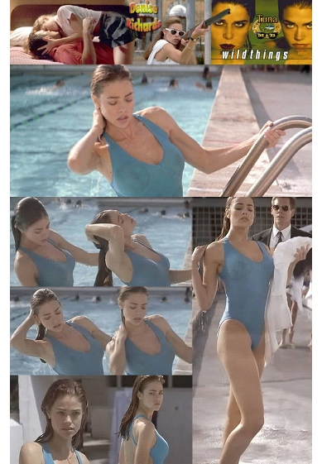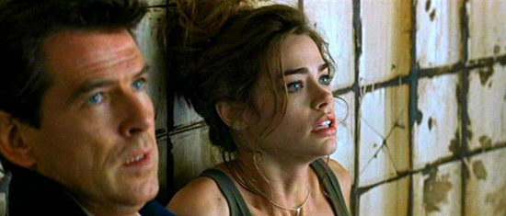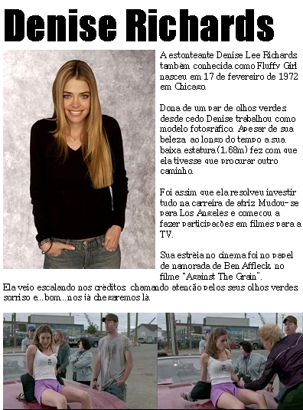
Cassie: I thought I heard voices. You must be Chandler.
Chandler: (transfixed) Hi! Nice to meet you!
Cassie: Nice to meet you too.
Monica: So, are you ready to go?
Cassie: Yeah.
(She lets her hair down and whips her hair around in Baywatch-esque slow motion with a Barry White song in the background. Chandler needless to say can’t help but stare along with the rest of the male and lesbian population of North America.)
-esque suf.(形容词词尾)表示"...式的"/Barry Eugene White (September 12, 1944 – July 4, 2003) was an American record producer and singer responsible for the creation of numerous hit soul and disco songs. He conducted the Love Unlimited Orchestra, which consisted of live musicians, including string and percussion(n.打击乐器) players. Records featuring White's deep bass voice and suave(adj. 温和的) delivery(n.表演形式) were often used by couples wishing to create a romantic ambience(n.气氛). He was often affectionately(adv.亲切地) referred to as the "Maestro(n.艺术大师)" and "Walrus(n.海象) of Love" or "The Man with the Velvet(adj.天鹅绒般柔软的) Voice". All inclusive record sales of White's music with singles, albums, compilation usage and paid digital downloads as a singer, songwriter and producer now exceed 100 million world-wide.

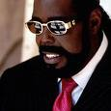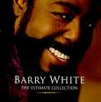
Monica: (catching him) Chandler!
Chandler: I’ll be right with you.
[Scene: Central Perk, Ross is there as Chandler and Monica enters.]
Monica: (To Ross) Cassie needs to stay at your place.
Ross: What—why?
Monica: Because Pervie Perverson over here can’t stop staring at her.
Pervie <俚>pervert/Pervie Perverson：固定的一种俚语用法 lovey loverson
Ross: What?! Chandler she’s our cousin!
Chandler: I was not staring at her. Okay? I was just listening intently. It’s called being a good conversationalist. Watch. (Stares at Monica’s eyes.) Say something.
conversationalist n.交谈者 健谈的人 口才好的人
Monica: You were staring about eight inches south of there.
Ross: Fine, she can stay at my place. By the way, what-what does Cassie even look like now.
Monica: She looks exactly like Aunt Marilyn.
Chandler: Umm, so this Aunt Marilyn is-is-is-is she coming to the wedding?
Monica: Wafer-thin ice!
wafer n.威化饼<电>薄片/wafer-thin a. 很薄的 极薄的/Wafer thin ice was probably a reference to the saying "You're skating on thin ice!" which basically means you're really close to getting me really mad.如履薄冰
[Scene: A Casting Director’s Office, Joey is entering for his callback.]
Joey: Hey, I’m back!
The Casting Director: Hi-hi Joey.
Joey: Uh so, will-will I be reading the same scene again?
The Casting Director: Actually, I tried to call you. You didn’t need to come down here today.
Joey: Oh great! Y’know I would’ve been perfect for this part, but whatever! Y’know, thanks for making a bad decision and ruining your movie! Good day! (Starts to leave.)
The Casting Director: Wait Joey! You didn’t need to come down because the director saw your tape from yesterday and loved it.
Joey: And scene! Huh? Wasn’t that fun? We did a little improv there. Yeah! Okay! So you-you-you-you were saying?
improv <俚>short for improvisation, a comedy format in which the performers make up the scene on the spot 即兴表演
The Casting Director: Well, the director thinks you’re really right for the part and wants to meet you tomorrow.
Joey: Wow! Sure! That’s great!
The Casting Director: Oh and your agent said you were okay with the nudity.
Joey: Yeah! Yeah sure, just as long as it’s handled tastefully and that barn is not too cold.
tastefully adv.高雅地
The Casting Director: Terrific! Well uh, there’s one more thing. Uhh, uh it’s really important to the director that everything in this movie is authentic. Yeah and so in your love scene with Sarah she talks about how she’s never seen a naked man who wasn’t Jewish. So… (Laughs.)
authentic adj.真实可信的 非假冒的[eg: They found this authentic manuscript of the book from an ancient tomb]
Joey: So…What?
The Casting Director: So uh well the director is insisting that whoever play that part be authentically, anatomically not Jewish. Do you know what I’m saying?
anatomically ad. 解剖学上 身体结构上/Anatomically Not Jewish: 乔伊接演的新角色必须是 真正的、解剖学上的非犹太人(anatomically not Jewish)。由于犹太人是出生就行割礼的，所以生殖器都没有包皮。所谓“解剖学上的非犹太人”就是没有行过割礼的，仍有包皮的。而最近几十年，美国几乎大多数小孩出生后都是实施割礼的,Joey当然也包括其中。所以才有后来的莫尼卡等人想办法帮助乔伊“补救”的一系列笑料/*割礼的历史背景*: 割阳皮手术，又称包皮环切术，简单地说就是切除男性阴茎上的包皮。这个手术有两方面的功用。一方面是医学上的功用，这个手术常常被用来治疗和预防某些男性疾病。另外一个功用是宗教方面的，一些宗教把割阳皮看作是男婴出生后一个非常重要的宗教仪式，例如犹太教就把割阳皮看作是割礼的一个重要内容。据圣经旧约记载，耶和华神和犹太人的先祖亚伯拉罕立约时，要求犹太人所有男子生下来第八天都要受割礼，作为他和亚伯拉罕及其后裔立约的证据。很多犹太人世世代代遵守这一规矩，为家中出生的男婴施行割礼。其它宗教信仰和民族出于不同的原因也有割阳皮的传统/*美国大多数男婴都行割礼*:上个世纪，90%的美国男婴出生后都被割阳皮，其中一部分人是出于宗教方面的原因，还有很多人是出于健康方面的考虑。当时一个比较流行的观念就是这个手术能够预防和治疗很多男性疾病，甚至可以防止性传播疾病的感染。菲利普.谢尔曼说：“早在1880年代，就有很多机要派基督徒就遵循圣经旧约的教导给他们的男婴行割礼，很多非宗教人士也给自己的孩子割阳皮。他们认为，割阳皮不仅可以治愈很多疾病，还可以提醒他们的孩子要行为检点，遵守道德。”不过，近年来，医学界对割阳皮的做法提出了质疑。美国儿科学会发表声明说，没有充足的证据表明出生男婴有必要进行常规的包皮环切术。目前，割阳皮的美国男婴人数据说已经从1970年的90%左右下降到目前的大约60%。而且，美国人已经开始尝试恢复包皮！（foreskin restoration），如果你在GOOGLE上搜索foreshin（包皮），你会找到大量的有关包皮恢复的信息，可悲的是如果你用中文搜索，则几乎找不到有关的信息！！！， 那为什么在中国还找不到这样的信息呢？原因很简单：商业利益。目前做环切的男性还不多，市场还是很巨大，在商业利益面前，医生鼓吹各种好处是可以理解的。但在这个问题上却剥夺了我们很大一部分的知情权！我们知道凡事有利必有弊，而我们的医生夸大了包皮的弊端，只要有包皮的人均以过长论处，是否有失公平？
Joey: Yes!
The Casting Director: Okay.
Joey: No. What?
The Casting Director: An Italian Catholic immigrant at this time would not be…
Joey: Bah mitzvah-ed?
A bah mitzvah is a Jewish tradition that takes place with a son turns 13. The joke is funny because they're talking about an Italian Catholic. Here's a little description I found, though I'm sure someone Jewish can answer this MUCH better than this: The definition is that at thirteen, a Jewish male regardless of whether he has any studies or anything, becomes an independent person, responsible on his own before God, he becomes an adult, where the religion is concerned. Regardless of how much he knows, what he does or what he says. But he's regarded as a person on his own, responsible for his actions. Before God, an action, he has certain responsibilities, and religious practices to perform. Regardless of what he had. . . education, of whether he had a formal celebration. But by the law, they, the old religion is set up, a man at thirteen, a boy at thirteen, becomes independent. Bah Mitzvah means "son of the commandments." He's responsible on his own. Judgment is coming from his own, the parents are not responsible for his sins or good deeds anymore.
The Casting Director: Think 13 years earlier, lose the rabbi, add a scalpel. (The casting director shakes her head.)
rabbi n.犹太教祭司/scalpel n.解剖刀
Joey：(finally realizes)Oooh
[Scene: Monica and Chandler's, Joey is telling Monica what the casting director was trying to get to.]
Monica: So to get this part you can’t be?
Joey: Nope.
Monica: But you are?
Joey: Yep.
Monica: But you told them you weren’t?
Joey: That’s right.
Monica: Wow! Wow! And it’s definitely all gone? There’s nothing there to work with? (Joey glares at her.) What were you thinking?
Joey: I don’t know! I really want this part! And they tell you no matter what you get asked at an audition you say yes. Like if-if they want you to ride a horse, you tell‘em you can! And just figure out how to do it later.
Monica: Joey! This is not like learning to ride a horse! This is like learning to…grow a turtleneck!
Joey: I kn-I know! I know! Okay? And apparently tomorrow when I go in to meet the director I have to take off my clothes so that they can see what my body looks like.
Monica: Oh my God, what are you gonna do?!
Joey: I just have to call my agent and tell her I can’t do the part. (Gets up for the phone.)
Monica: Unless!
Joey: Unless what?
Monica: Well, this may sound crazy, but there maybe something we could fashion.
fashion v.制作
Joey: Like what?
Monica: Well I’m not sure yet, but umm of the top of my head I’m thinking double-sided tape and some sort of luncheon meat.
double-sided tape n.透明胶/luncheon n.午餐

luncheon meat
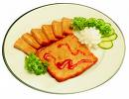
[Scene: Joey and Rachel's, Phoebe is entering and Rachel is still planning.]
Phoebe: Hey! I’ve got a great idea for party favors for the shower. Okay, we get some uh mahogany boxes and carve everyone’s names in them and inside is everyone’s individual birth stone.
mahogany n.<植>桃花心木
mahogany box
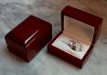
birthstone n.生日石 诞生石(一年12个月，每月出生的都有一个诞生石来保佑)
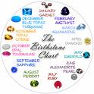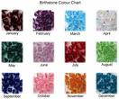
Rachel: Okay. Okay. All right, you take care of that. And meanwhile, the party is tomorrow and we still don’t have a guest list.
Phoebe: Okay. Okay! Well okay, who do we know that’s coming? Me. Are you?
Monica: (entering) Hey!
Phoebe: Hey!
Rachel: Hey! What’s up Mon?
Monica: Well uh, I’m trying to make something for Joey. Do you mind if I raid your fridge?
Rachel: Have at it.
have at v.攻击(=raid)
Monica: Okay. (Opens the fridge.) All right, turkey. Eh, that won’t work. Cheese? (Picks it up) That won’t work. Olive loaf? (Picks it up) I hope that won’t work.
Olive loaf
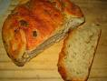
Rachel: Are you makin’him a sandwich?
Monica: No it’s umm, more like a wrap. Okay so uh, I’m gonna go guys.
Phoebe and Rachel: Okay.
Monica: I guess you can get back to deciding on what to get me for a present! (Runs out.)
Rachel: (To Phoebe, after Monica’s gone) We have to get her a present?!
Phoebe: Okay but look! Look at what I got! It’s her address book! (Holds it up.) We have a guest list!
address book n.通讯录 住址名册
Rachel: Oh my God you’re amazing! Did you just pull that out of her purse?
Phoebe: Uh-huh, and a little seed money for the party. (Holds up $40.)
seed money n.<经>种子基金 原始基金
[Scene: Ross's apartment, there is a knock on the door and Ross opens it to Cassie.]
Ross: (shocked at her beauty) Cassie?!
Cassie: Hey Ross!
Ross: Hey!
Cassie: (hugs him) It’s been so long! Last time I saw you, you were setting up your tent in line to see Return of the Jedi.
in line to 排队为了/Return of the Jedi:罗斯见到了好久未见的表妹，他们上次相遇还是在排队一起看《杰迪骑士归来》的时候。这是星球大战的第三部，在1983年公映时盛况空前，所以罗斯他们支起帐篷排队排队买票也不稀奇了/Star Wars Episode VI: Return of the Jedi is a 1983 space opera film(n.以太空探险为主题的电影) directed by Richard Marquand and written by George Lucas and Lawrence Kasdan. It is the third film released in the Star Wars saga, and the sixth and final in terms of internal chronology(n.年表).The film is set about one year after Star Wars Episode V: The Empire Strikes Back. Luke Skywalker and members of the Rebel Alliance travel to Tatooine to rescue their friend Han Solo from Jabba the Hutt. Meanwhile, the Galactic(adj.银河的) Empire is planning to crush the Rebel Alliance with a more powerful Death Star while the Rebel fleet(n.舰队) simultaneously prepares to launch a full-scale(adj.全面的) attack on this new space station. Luke confronts his father, Darth Vader, in a climactic(adj.高潮的) duel(n.决斗) before the evil Emperor Palpatine.The film's original theatrical release was on May 25, 1983, receiving mostly positive reviews. Several home video and theatrical releases and revisions to the film followed over the next 20 years. It was the last Star Wars film released until Star Wars Episode I: The Phantom Menace in 1999.
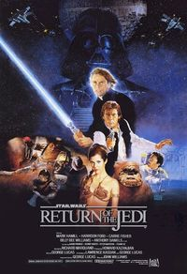
Ross: Oh. Oh, that’s right. So-so you did see me that day because it seemed like you didn’t.
Cassie: Ah yeah, sorry about that.
Ross: It’s okay. Come, come on in.
Cassie: Thanks for letting me stay here! I mean Monica’s place was nice, but her fiance sure stares a lot.
Ross: Oh.
(She sets down her bag and we travel back to slow motion world. She once again whips her hair around in slow motion with the love doctor Barry White singing in the background. And I’d also like to take this opportunity to mention that she can also be seen in Starship Troopers and that she was born in Downers Grove, Illinois which just happens to be a few miles from where I live. Anyway Cousin Ross is now staring.)
Starship Troopers is a 1997 film directed by Paul Verhoeven, written by Edward Neumeier, and starring Casper Van Dien, Dina Meyer and Denise Richards. The movie is loosely(=not exactly) based on the novel Starship Troopers by Robert A. Heinlein.
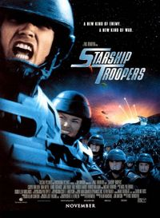
Cassie: Oh my God! You do a great Chandler!
Ross: Uh-huh. Yeah I-I have a knack for impressions.
knack n.本领 熟练的技巧(+for)[eg: He has a knack for making furniture]/impression n.(对名人等的漫画式)模仿
Cassie: Well, maybe after we get re-acquainted uh, you can do me.
reacquaint v.重新熟悉起来/do sb<俚>have sex with sb(此处是个pun)
Ross: Yeah—No!!
Commercial Break
[Scene: Ross's apartment, Cassie is eating dinner and Ross is pacing behind her because of what she’s eating.]
Ross: Cassie, how you-how you doin’on that…hot dog.
Cassie: I’m all done.
Ross: (quietly) Thank God.
Cassie: I guess the last time we really hung out was when our parents rented that beach house together.
Ross: Oh right. Right. Ooh, remember the time I uh, I pinned you down and tickled you‘til you cried? (She laughs) We’re probably too old to do that now.
Cassie: I’ll always remember that summer, because it’s when I got all of these freckles. (She pulls her blouse open to show him her shoulder and bra strap.)
freckle n.雀斑
bra strap
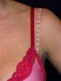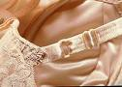
Ross: (looking then moving away quickly) Uh-huh! Uh-huh! And-and-and I’ll always remember that summer because that’s when I realized that we are related. You know, we're not just two random people thrown together.We share genetic material.
be related 是亲戚
Cassie: It took you that long to figure it out, huh?
Ross: Well I’m, I’m a little slow. (To himself) Just as our children would be.
slow adj.迟钝的
[Scene: Phoebe's apartment, it’s Monica’s bridal shower and Phoebe is passing out some finger food.]
finger food n.小零食

Phoebe: Hi!
Woman: Hi!
Phoebe: How are you? (The woman nods) Good. (She goes over to another couple of women.) Hi, thanks for coming.
Woman: Oh thank you.
(The other woman declines.)
Phoebe: Thank you. (To the other woman) No? (She nods.) All right. (She goes to another pairing.) Oh, it’s so nice to see you.
Woman: No.
The Other Woman: No thanks.
Phoebe: Okay. (Goes over to Rachel.) Hey Rach?
Rachel: Yeah?
Phoebe: Who the hell are all these people?
Rachel: Well, I don’t know. I called all the people in Monica’s phone book and these are the only ones who could show up on 24 hours notice.
on +(time)+notice 在…时间内
Phoebe: Hmm, y’know there’s another word for people like that. Losers!
(A woman approaches.)
Rachel: (to her) Hi! I’m Rachel. This is Phoebe. I’m the maid of honor. How do you know Monica?
Woman: I was her accountant four years ago.
accountant n.会计师(这里应该是指专门负责报税的)
Rachel: Ohhhh!
Woman: I’m very interested to find out who’s been doing her taxes these last four years.
Rachel: That’s great!
Woman: So, what time is Monica supposed to get here?
Phoebe and Rachel: (to each other) I don’t know.
Rachel: (to the woman) Excuse us for a minute. (They go into the kitchen.) You didn’t tell her to come?!
Phoebe: You were supposed to tell her!
Rachel: No I wasn’t! You were supposed to tell her to come and I was supposed to bring the cake!
Phoebe: Fine, I’ll go call her.
Rachel: Yes! And please tell her to bring a cake!
[Scene: Joey and Rachel's, Joey is standing at the counter as Monica enters carrying a tray.]
Monica: Okay, we have a lot of options here, a number of prototypes for you to try on.
Joey: Wow! This looks great!
Monica: Yeah! Okay, this one is a mushroom cap. (Points to it.) Umm, this one is made of bologna. (Points.)
mushroom cap n.蘑菇头
bologna n.含牛猪肉的熏制粗腊肠
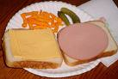
Joey: And-and-and-and-and the toothpicks?
toothpick n.牙签
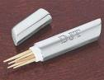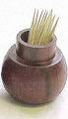
Monica: Oh, just until the glue dries.
Joey: Thank God!
Monica: (to a whole group) Now, these are-are more realistic, but perishable.
realistic adj.逼真的/perishable a.易腐烂的[eg: Fruits are perishable in transit]
Joey: Ah.
Monica: Okay? (To a different group) Over here we have pink suede, which is nice. But umm, if it gets wet then you know it’s gonna shrink.
suede n.仿麂皮织物
pink suede
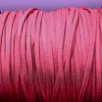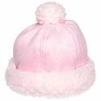
Joey: Well maybe we just take that one away. (Picks it up and throws it away.)
Monica: I also, did a little something in fur. But umm, that’s really just for me. (Rubs it against her cheek.) Okay. So, why don’t you go into your room and try these on and we’ll see—get a better idea of what’s gonna work.
Joey: Thanks, you are such a good friend. And this is so weird.
(He goes into his room to try them on and closes the door.)
Joey: Okay, the taffy's too sticky.
sticky adj.粘的
taffy n.太妃糖 乳脂糖

Monica: I was afraid of that.
I was afraid of that: 我刚才就觉得有问题
Joey: Ow!
Monica: Toothpick?
Joey: Yeah.
Monica: What are you trying on now?
Joey: The fruit roll-up.
fruit roll-up n.水果卷

Monica: And?
Joey: Delicious.
Monica: Joey!
Joey: Wait a minute! Wait a minute! We have a winner!
Monica: What?! Which one?!
Joey: The Silly Putty! It’s not so silly anymore! (They hug.)
Silly Putty：这是一种类似橡皮泥的东西，是液体，但又像固体，可以缓慢地被拉伸，比橡胶的回弹能力更强，不会腐烂。这种东西起先是供科学家做实验用的，但最后却成为了消费者的宠物，可以用来制作各种玩比如橡胶彩蛋，怎么捏都成，可以用来搞蛇啊蜘蛛啊，还能Halloween的时候贴脸上。剧中乔伊准备用它来做自己的假包皮/ Silly Putty (originally called nutty putty, and also known as Potty Putty) is a silicone[n.<化>硅树脂] plastic, marketed today as a toy for children, but originally created as a fortuitous(adj.偶然的) accident during the course of research into potential rubber substitutes for use by the United States during World War II.
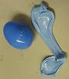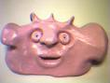
[Scene: Ross's apartment, Cassie and Ross are watching a movie and Cassie is pouring Ross some more wine as Ross has his hands full with the glass and holding the bowl of popcorn in his lap.]
Ross: (in his head) She’s your cousin. She’s your cousin! If she knew what was going on in your head she’d think you were sick! (She grabs some popcorn.) Or would she? Let’s back up a second. She was the one who suggested opening a bottle of wine. She was the one who turned down the lights. She was the one that wanted to rent Logan’s Run, the sexiest movie ever. (She grabs the blanket from behind him and looks at him.) Oh, I know that look. Forget it. I want it. She wants it. I’m going in.
sick adj.病态的/back up v.倒退/Logan's Run：罗斯在和表妹看电影时动了邪念，他给自己的理由是：是她自己要一起看《洛根的逃跑(Logan's Run)》这本最性感的电影的。《洛根的逃跑》是1976年的一本科幻电影，描写未来生活的荒诞场景，它并不能算是最性感的电影/Logan's Run is a 1976 science fiction film based on the novel of the same name by William F. Nolan and George Clayton Johnson. It depicts a dystopian(adj.反面乌托邦的) future society in which population and the consumption of resources is managed and maintained in equilibrium(n.平衡 平静) by the simple expediency(n.私利) of killing everyone who reaches the age of thirty, thus neatly (and inhumanely) avoiding the issue of overpopulation which was of growing concern at the time. The story follows the actions of Logan, a "Sandman", as he "runs" from society's lethal(adj.致命的) demand.The 1976 film version, directed by Michael Anderson and starring Michael York, Richard Jordan, and Jenny Agutter, was shot primarily in the Dallas/Fort Worth Metroplex (including locations such as the Fort Worth Water Gardens and the Dallas Market Center) between June and September 1975. The film only uses the basic premise(n.前提 预设) from the novel (everyone must die at a specific age, Logan runs with Jessica as his companion while being chased by Francis). The motivations of the characters are quite different in the film.The film won an Academy Award for Special Achievement for its visual effects, and was nominated for two other Oscars. It received the Saturn Award for Best Science Fiction Film, and was nominated to receive a Nebula Award for Best Script.Since 1994, a remake of the film has been in development hell.
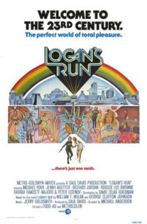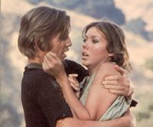
(They exchange looks, smile, and shrug their shoulders before Ross suddenly lunges forward in an attempt to kiss her, but she expertly backs away.)
lunge vi.冲 扑[eg: He lunged at me with a knife]/expertly adv.熟练地
Cassie: Hey! What the hell are you doing?! (They sit back up.)
Ross: (in his head) Say something clever! (Pause.) Okay, doesn’t have to be clever, it just has to be words. Say some words. (Pause) Any words will do. (Pause) Oh my God! This is the longest that anyone has not talked ever! (Pause) There is nothing you can say to make this worse!! So just say something!! (Pause.) (To her) I-I, I uh haven’t had sex in a very long time. (She leaves disgustedly.) (In his head) Yeah, you really shouldn’t have said anything.
[Scene: outside Phoebe's apartment, Monica is knocking on the door.]
Monica: Phoebe! Rachel! It’s Monica! I wonder what you could possibly need me for on such short notice! (She bursts into the apartment to find only Phoebe and Rachel sitting on the couch.) Oh.
on short notice adv.忽然 急忙
Rachel: Oh Monica, we are so sorry.
Monica: For what?
Rachel: Well first, for forgetting to throw you a bridal shower.
Phoebe: And then for forgetting to invite you to it.
Monica: You al-you already had it?
Phoebe: Yeah. Well, we called everyone in your phone book and bunch of people came, but it took us so long to get you here that they-they had to leave.
Rachel: Yeah, we wanted to throw you a big surprise and a great shower, and now you don’t have either.
Phoebe: We ruined everything.
Rachel: Ugh…
Monica: Well no wait a minute that’s not true! No, what did, that was really sweet. And it kinda works out for the best.
Rachel: What do you, what do you mean?
Monica: Well now, I get to spend my shower with the only people I really love! I mean, I get all those presents (Motions to the pile in the corner) without having to talk to people I don’t even like!
(Suddenly, everyone stands up and comes out of hiding. All of them are glaring at Monica.)
come out of hiding v.从躲藏处出来
Rachel: Surprise…
Phoebe: Sur-surprise.
Rachel: …Monica.
[Scene: The casting director’s office, Joey is there to show off to the director, so to speak.]
show off v.卖弄 炫耀/so to speak <插入语>可以说 所谓
Joey: And what’s cool is, the character is from Naples, right?
Naples is the capital city of the Campania region and the Province of Naples. Its ancient name was Neapolis, that is "new city". Its metropolitan area is the second most populated in Italy and one of the largest in Europe. It is located halfway between the volcano, Vesuvius[n.维苏威火山(位于意大利西南部 是欧洲大陆唯一的活火山)] and a separate volcanic area, the Campi Flegrei, both of which form part of the Campanian volcanic arc.The city itself in the central area has a population of around 1 million, the inhabitants are known as Neapolitans, or poetically(adv.有诗韵地) partenopei. It is rich in historical, artistic and cultural traditions and gastronomy(n.烹饪 美食). The Neapolitan language is the geographically most diffuse(adj.散播的) Italian language, similar variations of the Neapolitan dialect are spoken throughout most of Southern Italy.Between 1266 and 1861, Naples was the capital town of the Kingdom of Naples (later of the Two Sicilies), usually simply indicated as "the Kingdom", other Italian states having different denominations(n.命名). This history, coupled with(v.外加) its size, has given Naples the unofficial status of being the capital of the Italian South (Mezzogiorno).In the modern day, the city is served by Naples International Airport at Capodichino, a civil airport hosted by a military one, once outside the town, now surrounded by built up area. 那不勒斯(意大利南部港市)

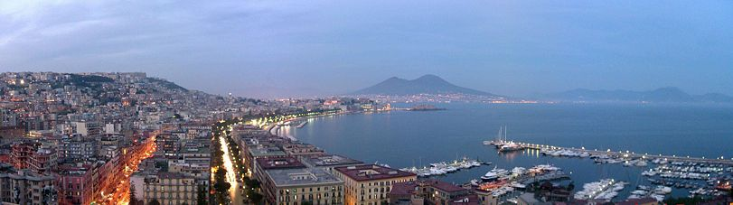
The Director: Yeah.
Joey: My whole family’s from Naples!
The Director: Oh that’s great! Okay, well I’ve heard everything I need to hear. I just need to uh, Leslie…
The Casting Director: Joey, this is awkward part.
Joey: Oh! Hey right! Not a problem. (He starts taking off his clothes.) I totally understand. You need to y’know make sure I don’t have any horrible scars or tattoos. Don’t you worry; I have nothing to hide. (He drops his pants and stands back up and looks down.) So there you go, that’s me. (We cut to a camera angle looking at the casting director and movie director through Joey’s legs.) One hundred percent natural! (Suddenly, there’s a thud as something falls off.) (Everyone is shocked.) I tell ya, that has never happened before.
thud n.砰击声 重击
Ending Credits
[Scene: Phoebe's apartment, Phoebe is getting out linens for Cassie who is in the bathroom.]
linen n.亚麻布制品(如床单 桌巾 卫生纸 内衣等)[eg: We change bed linen every week]
Phoebe: Cassie, are you finding everything okay in there?
Cassie: Yeah! Thank you so much for letting me stay here.
Phoebe: Oh! No problem! I… (Cassie emerges from the bathroom and we once again visit slow motion Barry White background music land with the sexy hair-flipping thing going on, only this time Phoebe is entranced. For more information on Denise Richards you can visit your local library or look her up on the Internet at her official website at www.deniserichards.com.)
emerge from v.自…出现/entrance vt.令(人)出神 使陶醉 使狂喜[eg: She was entranced with the music]
Cassie: (noticing her) What?
Phoebe: (in her head) Say something! Say anything! Ask her out! She’s not your cousin!
End

